Create Security Group for EFS
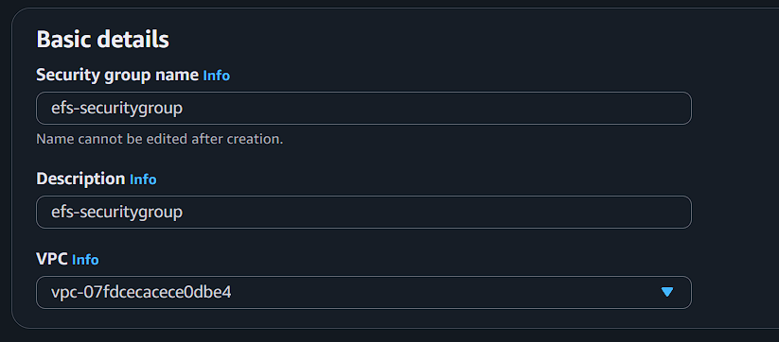

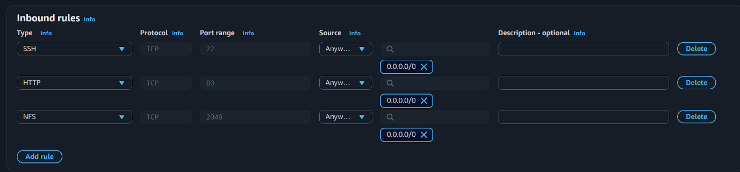

Create EFS File System
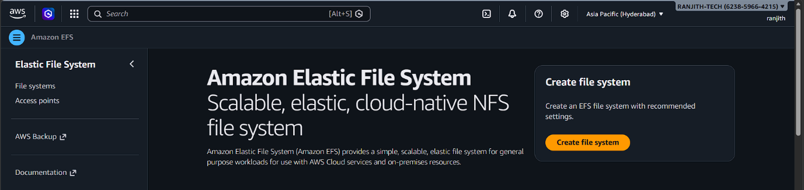

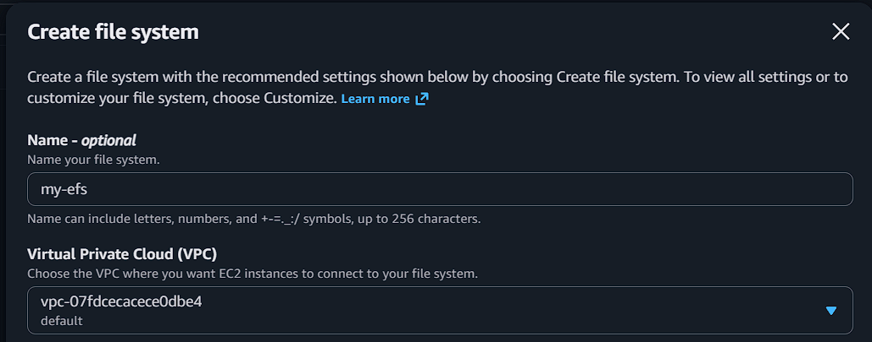

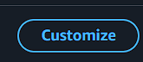
OR
Default Setting
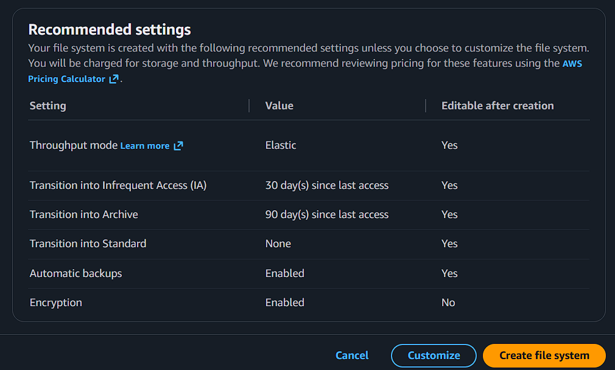
Customize
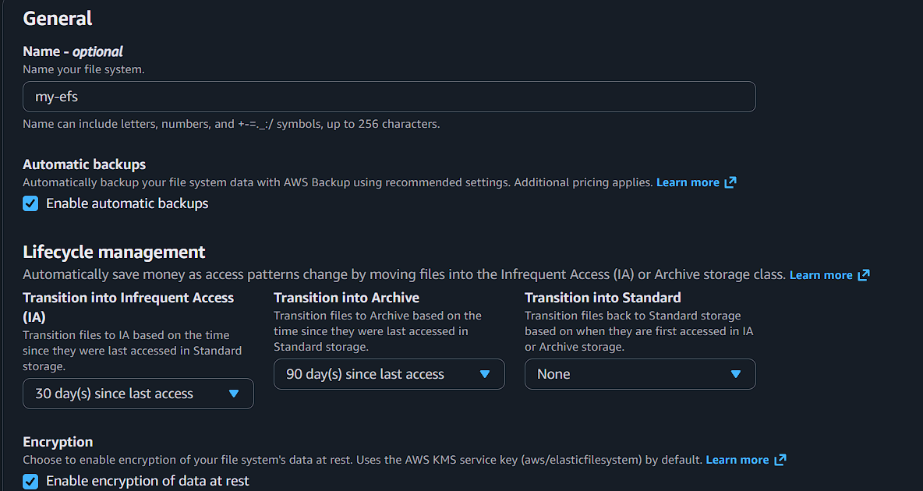
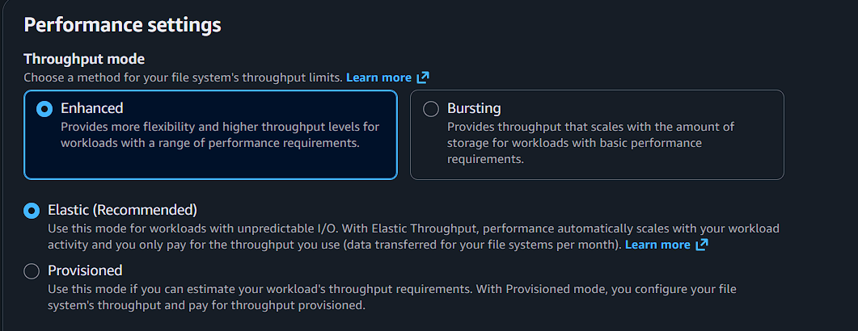

Add security for 2049 port attached sg(NFS)
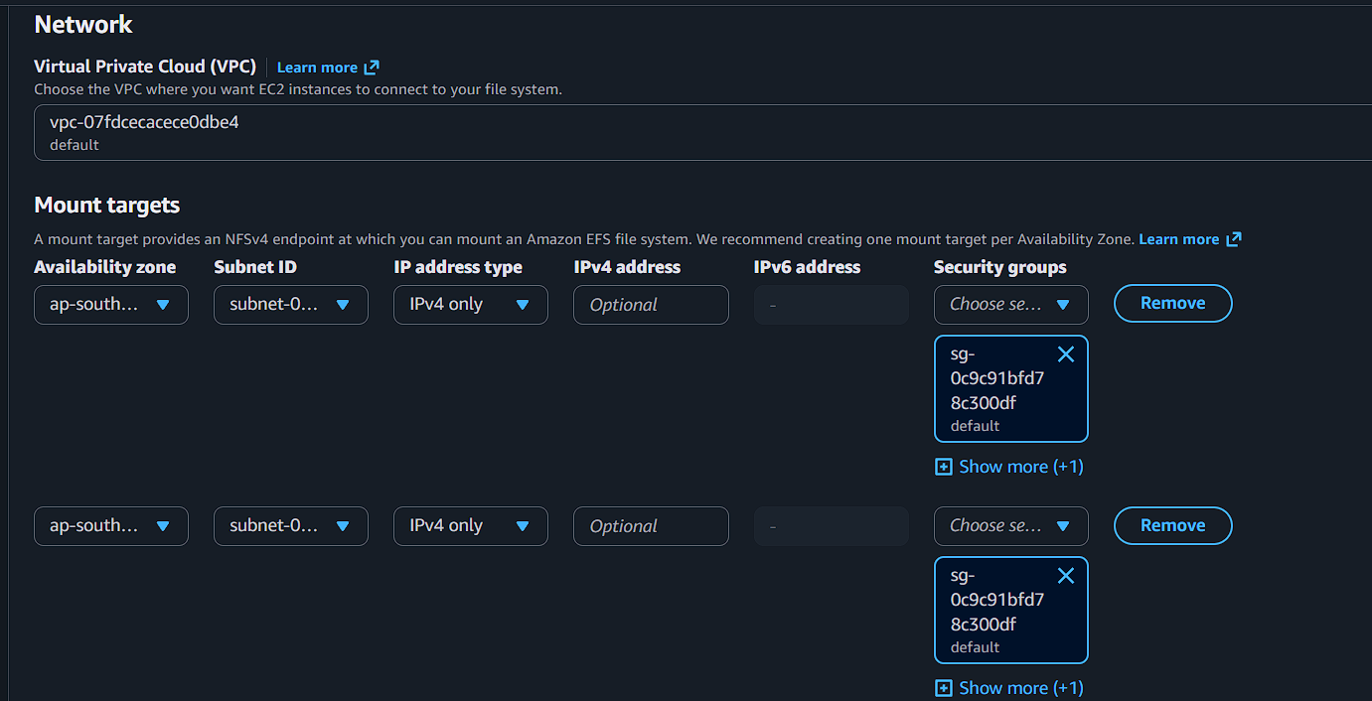

Check all details then CLICK enter


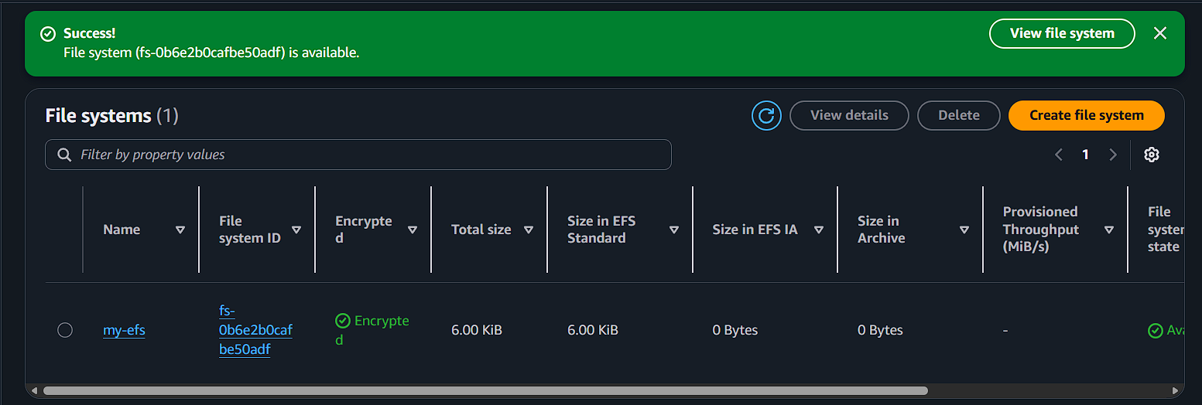

Create EC2 Instance 1
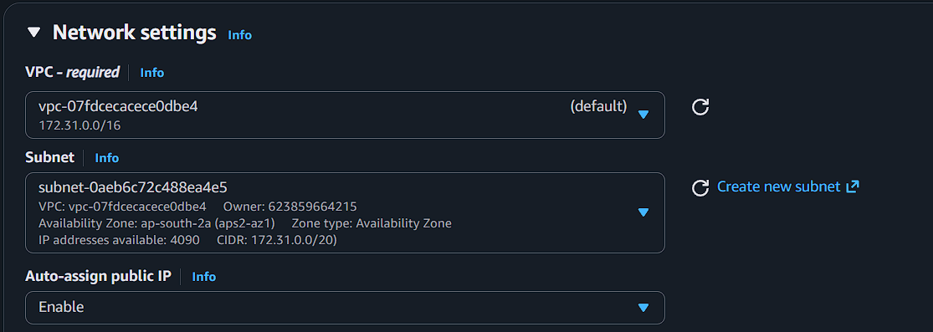

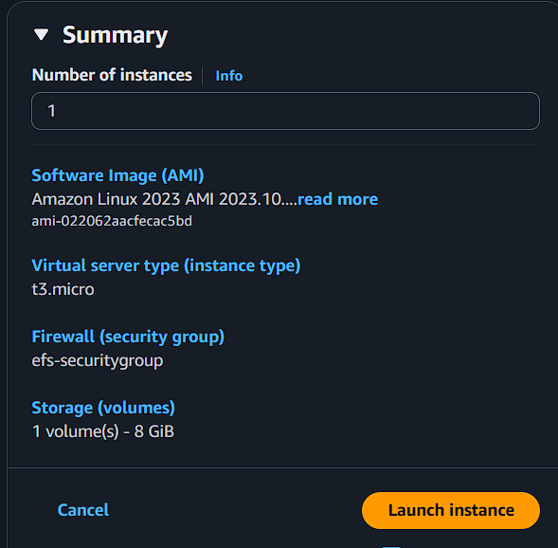

Create EC2 Instance 2
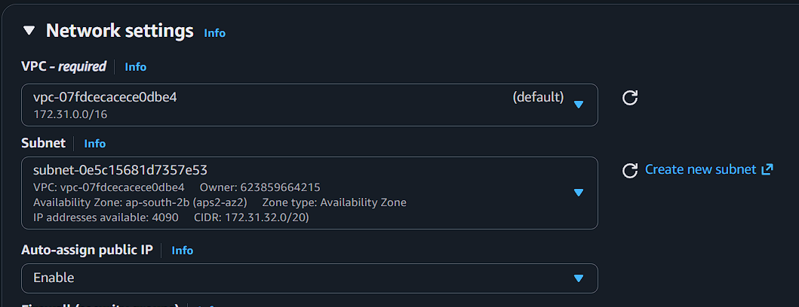

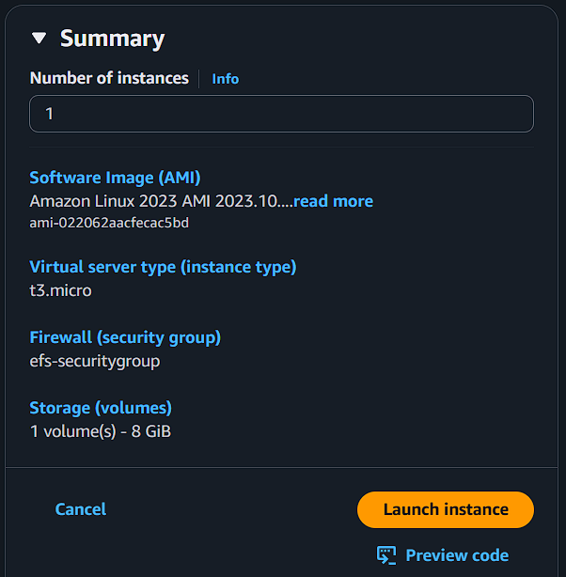

Connect to EC2
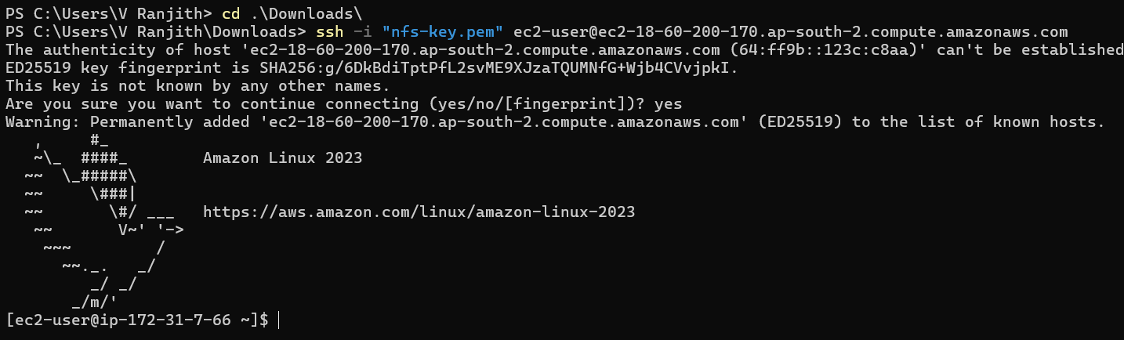

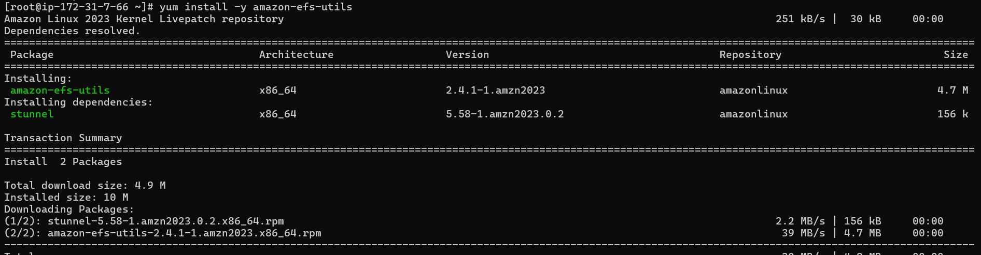

Create Mount Directory
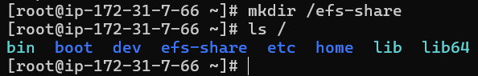
Mount EFS
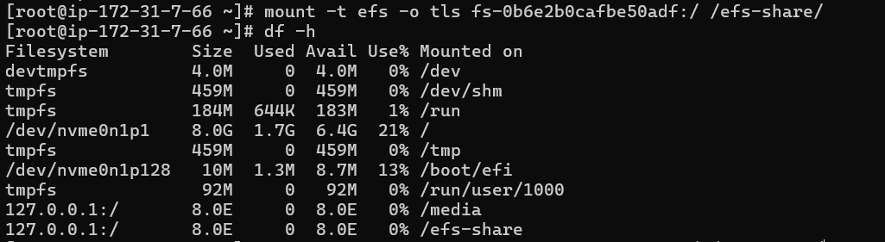

Add Permanent Mount (fstab)
Create Data on EC2-1
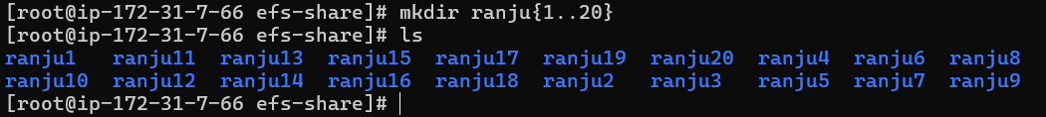

Validate from EC2-2
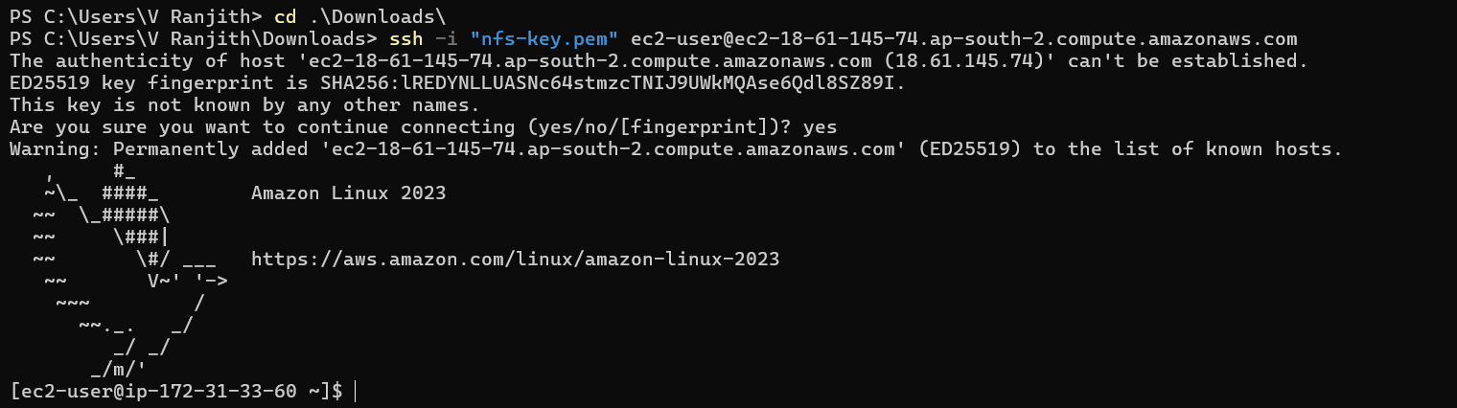

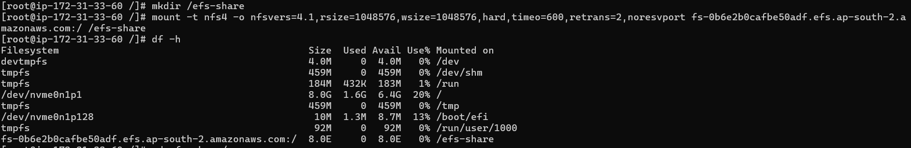

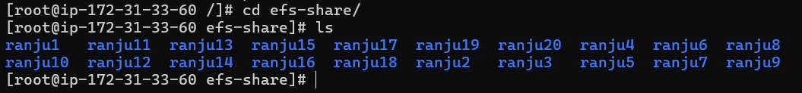

Test Reverse Write
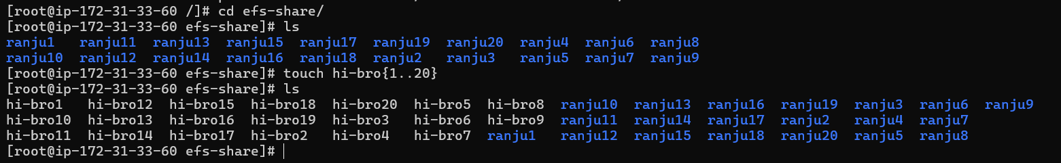

SWITCH THE INSTANCE EC2-1
Check the directory
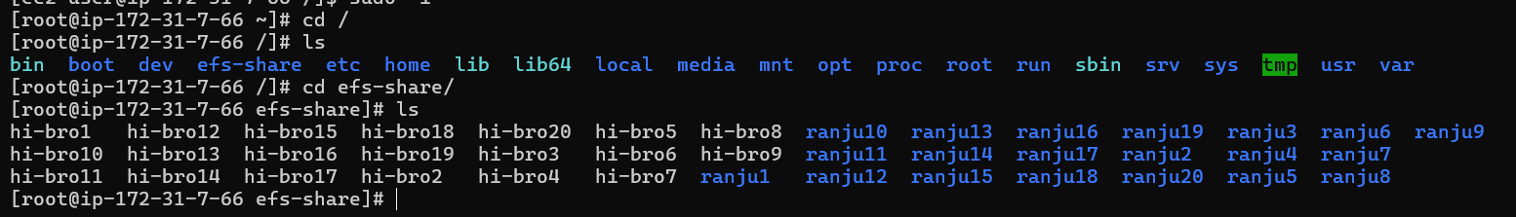

Validation Commands
Check mount
df -h
Check NFS mount
mount | grep efs
Check storage
ls -ltr /efs-share

